**B**

**A**

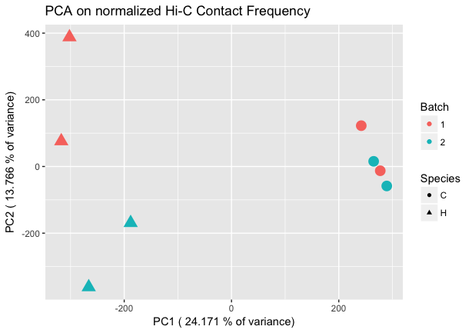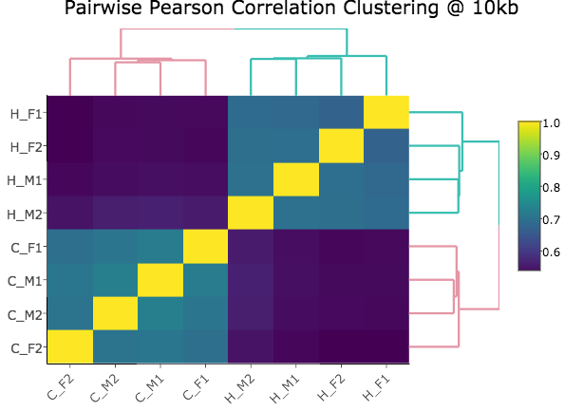

**Figure 1. Regulatory landscapes cluster by species.**

**A: Principal components analysis (PCA)** of Homer-normalized interaction frequencies for the union of all significant hits between humans (H) and chimpanzees (C). PCA is a dimensional reduction technique where the first principal component (PC1) encapsulates as much of the variability in the data as possible, and subsequent PCs capture less. Here, PC1 captures ~24% of the variance, and appears to be highly correlated with species, separating the humans (H) in triangles from the chimps (C) in circles. Neither PC2 nor any of the other lower PCs showed strong correlations with batch or sex, suggesting that species is a strong driving factor in determining interaction frequency. This result was robust to filtering out hits where liftOver introduced genomic distance or bin size differences.

**B: Unsupervised hierarchical clustering** at 10 kbof the pairwise Pearson correlations between Homer-normalized interaction frequencies. Pairwise Euclidean distances between samples are calculated, followed by complete agglomeration to produce hierarchical clustering results. Here, humans and chimps cluster separately, with chimp interaction frequencies being more highly correlated with other chimp interaction frequencies, and the same being true for humans. The first letter in the labels demarcates the species as above, and the following symbols indicate sex (male, M or female, F) and batch (1 or 2). This clustering result was also found to be robust to filtering out hits where liftOver introduced genomic distance or bin size differences. Scale on the right represents Pearson correlation values.

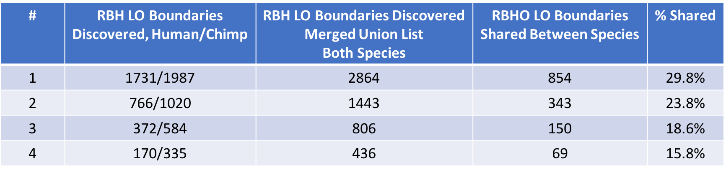

**B**

**A**

**Figure 3. Differentially expressed genes show enrichment for differential Hi-C contacts.**

**A:** Enrichment of differential expression (DE) in genes with differential Hi-C contact (DHiC). Top panel shows the proportion of DHiC genes that are also DE on the y-axis, across a range of FDRs for Hi-C linear modeling on the x-axis. Differently colored lines indicate different thresholds for DE, and dashed lines indicate the expected proportion of DHiC genes that would be DE based on conditional probability alone. A spike in the proportion of DHiC genes that are DE at a low Hi-C FDR, as seen here, indicates that species-specific contacts are indeed enriched for species-specific expression. Bottom panel shows –log10 chi-squared test p-values for enrichment of DHiC in DE genes on the y-axis across a range of Hi-C FDRs on the x-axis. Colors once again indicate different DE thresholds, and a horizontal red line is drawn where p=0.05. For two of the less stringent DE FDRs (5% and 7.5%), statistically significant enrichment of DHiC in DE genes is seen around 20% Hi-C FDR. (I shouldn’t be trying to explain the statistically significant enrichments at higher DHiC FDRs, right? Makes me wonder if the x-axis here should be shrunk to not see them at all in the paper). Because a given Hi-C bin overlapping a gene often makes contact with multiple other bins in the cross-species union of significant hits dataset, some kind of summary must be chosen to assess DHiC for a gene. Here, the contact with the minimum FDR value for species from Hi-C linear modeling was chosen, based on the assumption that these contacts should more accurately represent regulatory landscape divergence between species.

**B:** Same as in A, but this time, a weighted p-value combination techniqueref was used to integrate each Hi-C bin’s FDR across all its contacts. As a result, a more persistent enrichment is seen as Hi-C FDR increases. (this sentence won’t be necessary if we only go to 0.3 on x-axis or something in paper)

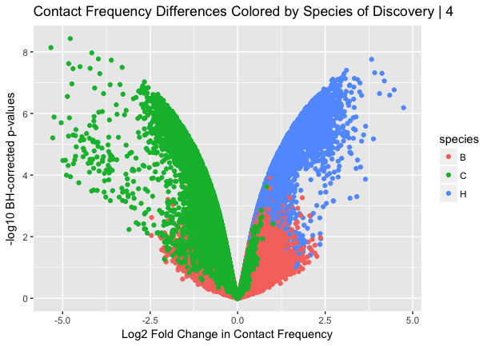

**Figure 2. Linear modeling reveals large-scale chromosomal differences in regulation.**

**A: Volcano plot** showing log2 fold change in interaction frequency on the x-axis, and Benjamini-Hochberg corrected –log10 p-values on the y axis. Hits are colored by the species in which they were discovered significant in Homer (B-both, C-chimpanzees, H-humans). Humans are coded as a 1 in the linear model, meaning hits on the left side of the plot represent pairs with marked decrease in contact frequency in humans as compared to chimps, and the inverse on the right side. Reassuringly, the majority of hits that show significantly higher contact frequency in humans were discovered as significant by Homer in humans, and the same was true for chimps, as expected.

**B: Chromosome-by-chromosome volcano plot** as in left panel.Initial creation of the volcano plot before filtering out more hits (supplementary Fig. 3) showed strong asymmetry, with many more strong effect size hits representing a decrease in contact frequency in humans compared to chimps (i.e. a buildup of points on the left side of the plot). This observation suggested doing a chromosome-by-chromosome analysis, with the expectation being that asymmetry would be uniformly distributed if it were a global feature of contact differences in humans and chimpanzees. Here, we see a subset of specific chromosomes showing distinct asymmetry patterns, suggesting large-scale chromosomal differences in regulation. Interestingly, some of these chromosomes are known to have undergone large-scale changes between the human and chimpanzee lineages, such as the putative fusion event at chromosome 2, or the pericentric inversions in chromosomes 4, 5, 15, 16, 17, and 18.67-72

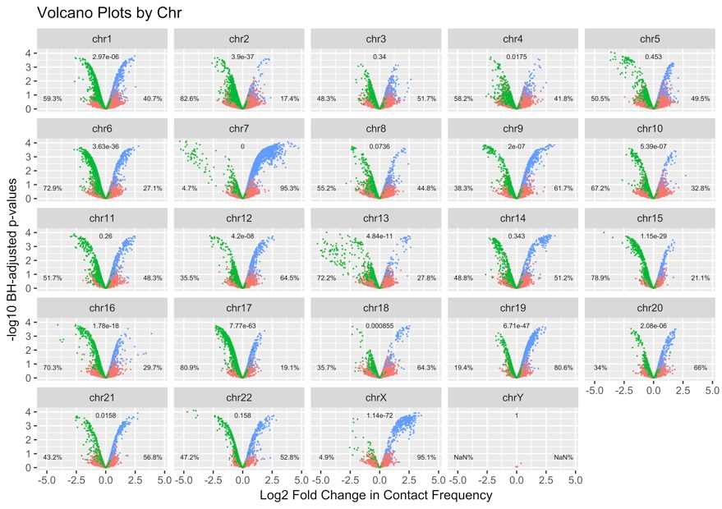

**C**

**D**

**B**

**Figure 3. Higher-Order Chromosomal Structure Differs Substantially Between Humans and Chimpanzees**

**A:** Table examining shared TAD boundaries across species. Left-most column (#) denotes results obtained with different restriction metrics (i.e. boundaries must be independently discovered in at least 1, 2, 3, or all 4 individuals within a species). Reciprocal best hits liftOver (RBH LO) was used to restrict our comparisons to only boundaries that could be reciprocally mapped between the species. We then merged all the coordinates from each species to find the union list of boundaries. The shared boundaries was calculated by intersecting the original boundaries from each species with the RBH LO boundaries from the other species in their respective genomes.

**B:** Total number of TADs called by TopDom in each individual (y-axis) across 3 window sizes (x-axis, 50kb, 100kb, and 200kb). Numerical values on plot represent significance assessments from t-tests for differences in the mean between the entire distribution of human sizes and the entire distribution of chimp sizes at each window. Again, we only compared TADs that could be reciprocally mapped across the species.

**C:** Same as in B, but this time with mean TAD size rather than number of TADs discovered. We note that, as expected based on observing more TADs in chimpanzees in A, the mean size of chimpanzee TADs is much smaller than the mean size of human TADs.

**D:** Direct quantitative assessment of the TAD size distributions across individuals and between species. TAD size shown on the x-axis, and density on the y-axis. Numerical value again represents significance of a t-test of difference in the mean for the whole human size distribution vs. the mean for the whole chimpanzee size distribution. As is revealed from C, humans tend to have much larger TADs than chimpanzees.

**A**

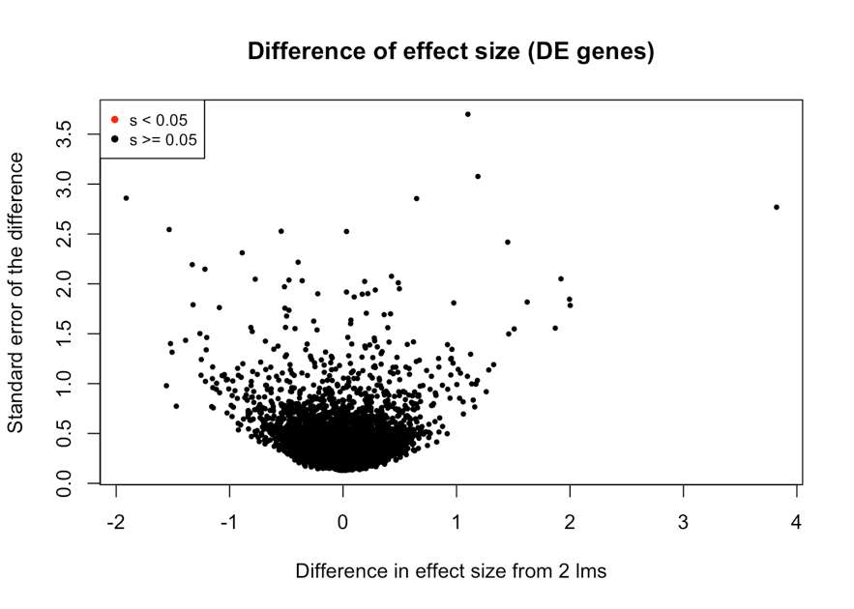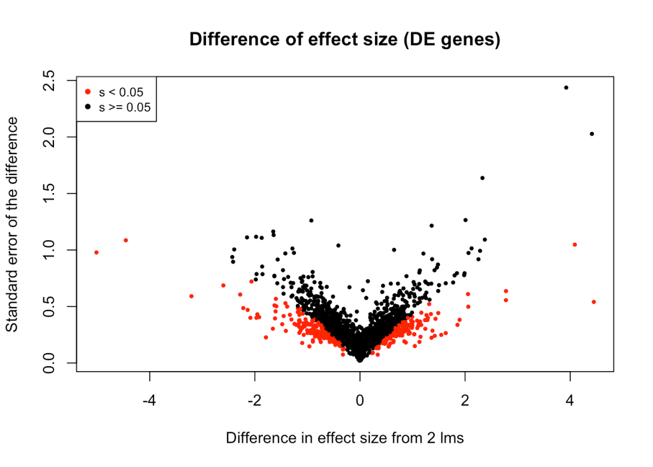

**Figure 4. Differentially expressed genes show enrichment for differential Hi-C contacts.**

**A:** Enrichment of differential expression (DE) in genes with differential Hi-C contact (DHiC). Top panel shows the proportion of DHiC genes that are also DE on the y-axis, across a range of FDRs for Hi-C linear modeling on the x-axis. Differently colored lines indicate different thresholds for DE, and dashed lines indicate the expected proportion of DHiC genes that would be DE based on conditional probability alone. A spike in the proportion of DHiC genes that are DE at a low Hi-C FDR, as seen here, indicates that species-specific contacts are indeed enriched for species-specific expression. Bottom panel shows –log10 chi-squared test p-values for enrichment of DHiC in DE genes on the y-axis across a range of Hi-C FDRs on the x-axis. Colors once again indicate different DE thresholds, and a horizontal red line is drawn where p=0.05. For two of the less stringent DE FDRs (5% and 7.5%), statistically significant enrichment of DHiC in DE genes is seen around 20% Hi-C FDR. (I shouldn’t be trying to explain the statistically significant enrichments at higher DHiC FDRs, right? Makes me wonder if the x-axis here should be shrunk to not see them at all in the paper). Because a given Hi-C bin overlapping a gene often makes contact with multiple other bins in the cross-species union of significant hits dataset, some kind of summary must be chosen to assess DHiC for a gene. Here, the contact with the minimum FDR value for species from Hi-C linear modeling was chosen, based on the assumption that these contacts should more accurately represent regulatory landscape divergence between species.

**B:** Same as in A, but this time, a weighted p-value combination techniqueref was used to integrate each Hi-C bin’s FDR across all its contacts. As a result, a more persistent enrichment is seen as Hi-C FDR increases. (this sentence won’t be necessary if we only go to 0.3 on x-axis or something in paper)

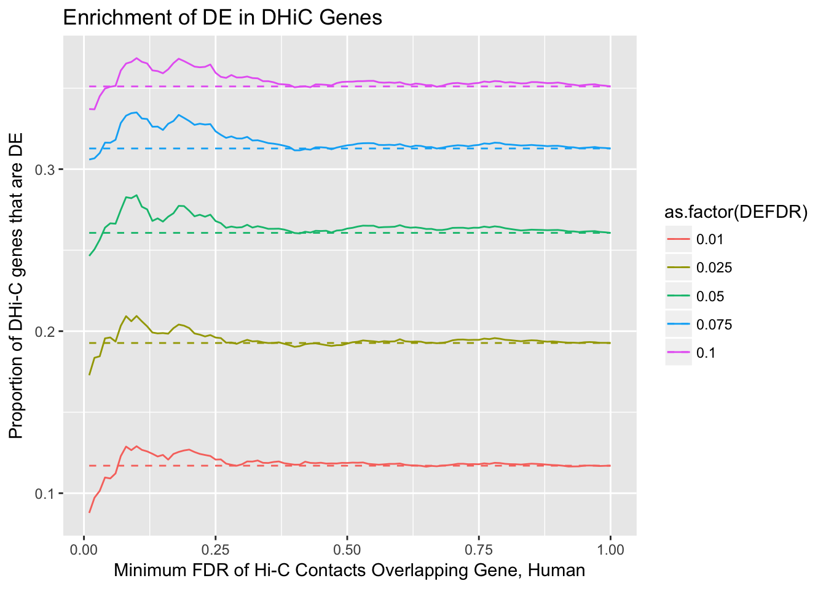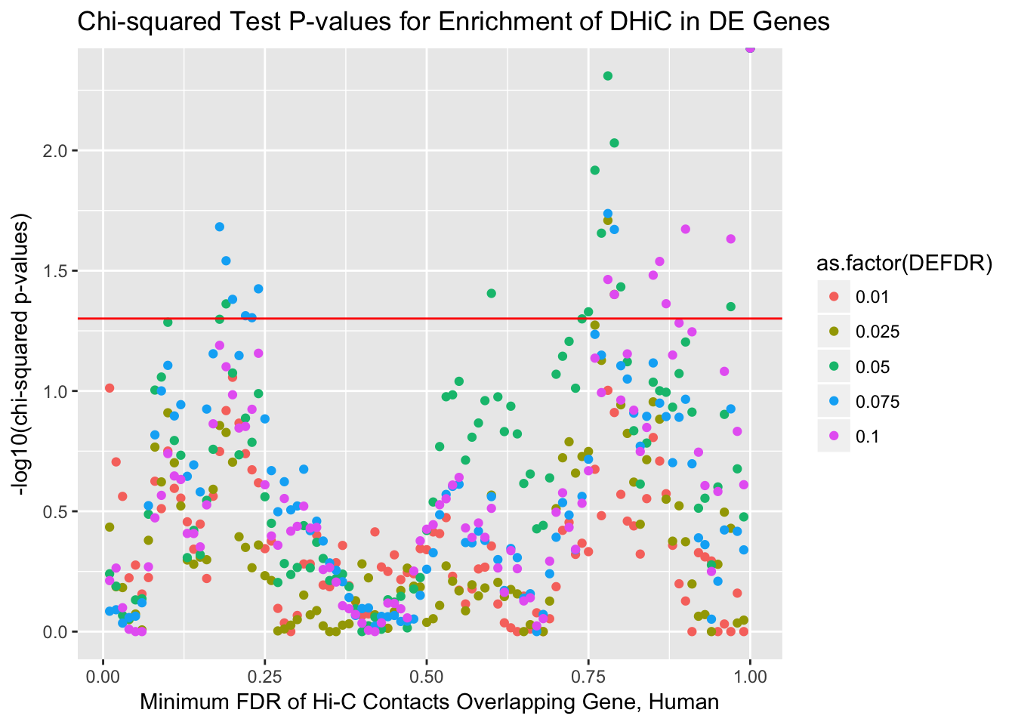

**A**

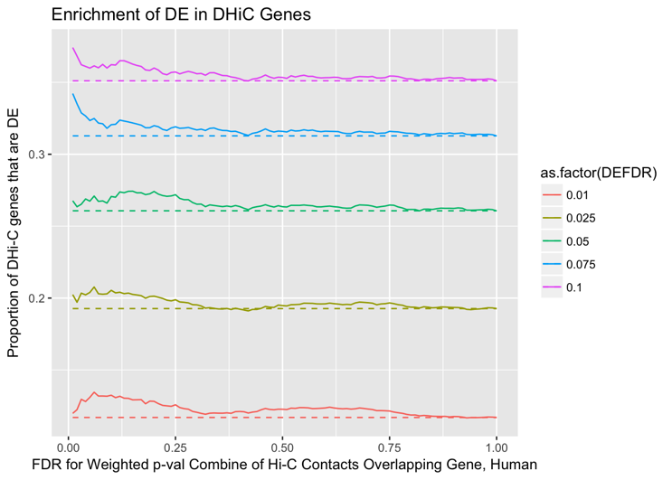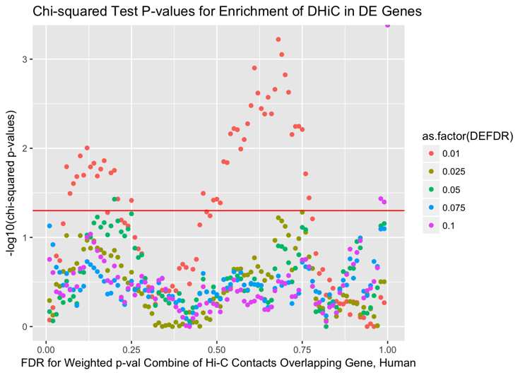

**B**

**B**

**A**

**Figure 5. Testing for a Difference in Effect Size from Two Linear Models.**

**A**: Differences in effect size between the two models (basal expression and “Hi-C corrected” expression) on x-axis and standard error of the difference on y-axis. We evaluated the statistical significance of these differences in effect size under the two different paradigms using adaptive shrinkage to shrink the variances and effect sizes. Genes with an s-value < 0.05 are those for which a significant effect is observed, and moreover we are able to have confidence in the direction of the effect. Amongst DE genes, 294/1537 genes showed a statistically significant and sign-confident effect of Hi-C contacts on expression levels. These data suggest that approximately 19% of DE genes could have much of their variance in expression levels explained by Hi-C contacts.

**B:** Same as in left panel, but performed on the set of non-DE genes. In this case, none of the 6,227 genes showed a statistically significant difference in effect sizes between the two models.

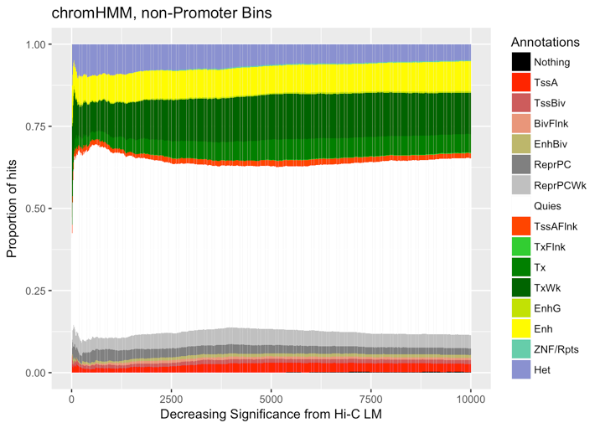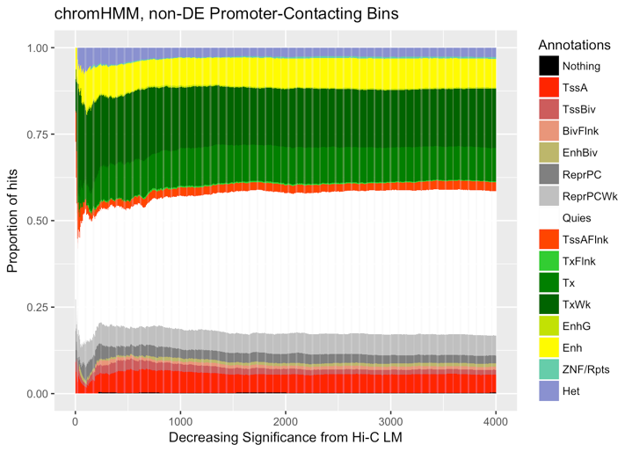

**A**

**B**

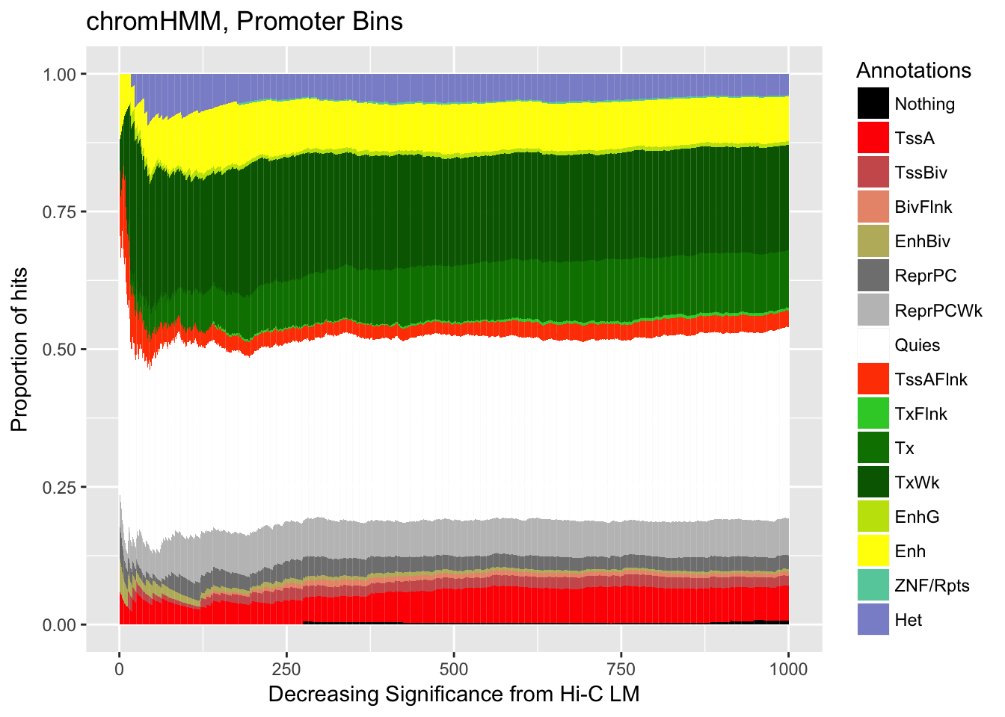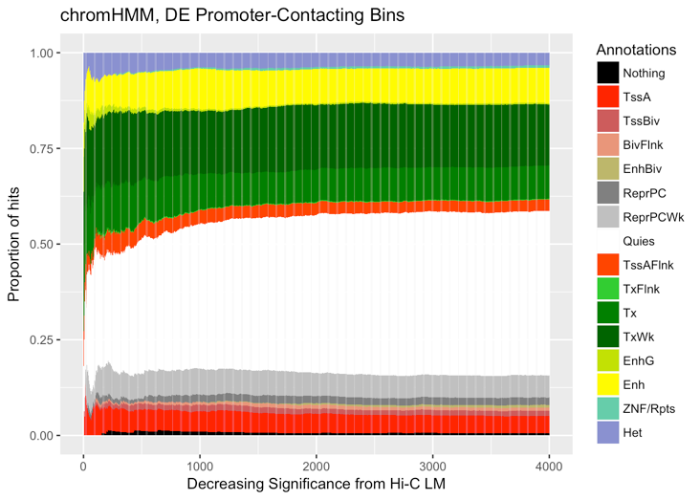

**Figure 6. Dynamics of chromHMM State Amongst Significant Hi-C Contact Loci**

**A:** Shown along the X-axis is the rank of Hi-C contact loci, with more species-specific contacts (i.e. lower FDR for our species term from linear modeling) on the left, decreasing in significance towards the right. Y-axis shows cumulative proportion of chromHMM annotation assignments for all Hi-C loci at the given rank or lower. Top panel shows these dynamics for Hi-C loci that do not contact a promoter, and the bottom panel displays the same for Hi-C loci that do make contact with a promoter. Of particular note are differences between the two panels in terms of the proportion of hits with annotations related to transcription and active gene regulation. As expected, the Hi-C loci contacting promoters tend to have a higher proportion of these annotations than do the loci not making contact with promoters.

**B:** Similar graphs as in A, but now, subset down to only the Hi-C contact loci that contact a promoter, and split between those promoters that show evidence for DE (bottom panel) vs. those that do not (top panel). As we anticipate, differences in chromHMM state assignment dynamics between these two classes are not as stark as the differences in A. Still, the DE-overlapping loci appear to have slightly higher proportions of chromHMM marks associated with enhancers and transcription.

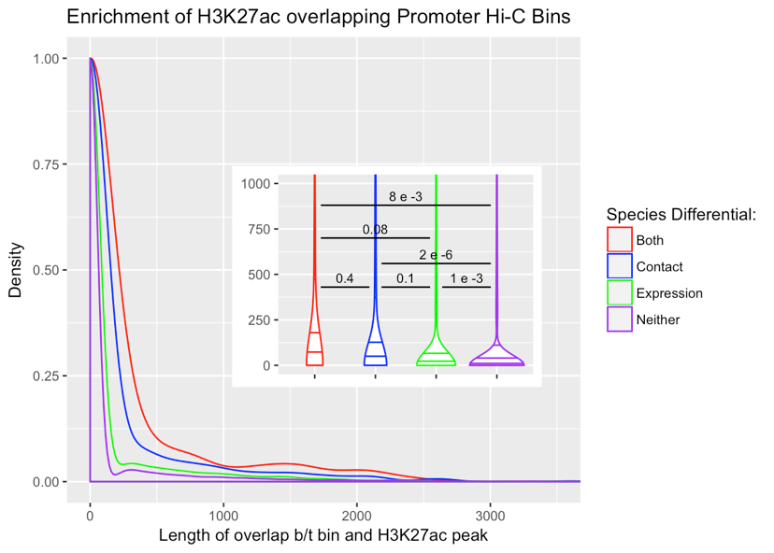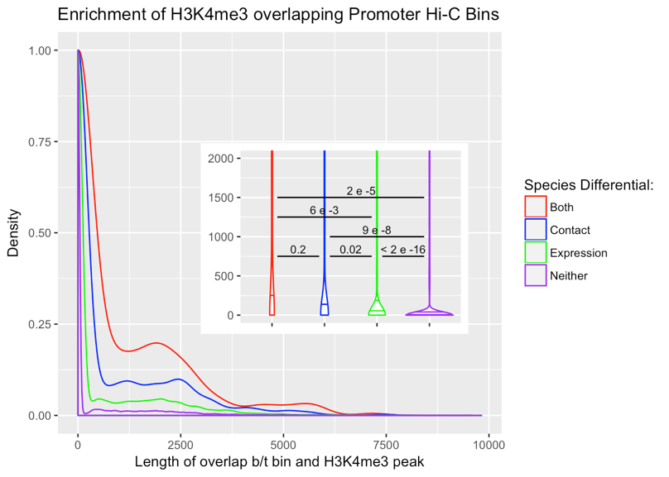

**A**

**B**

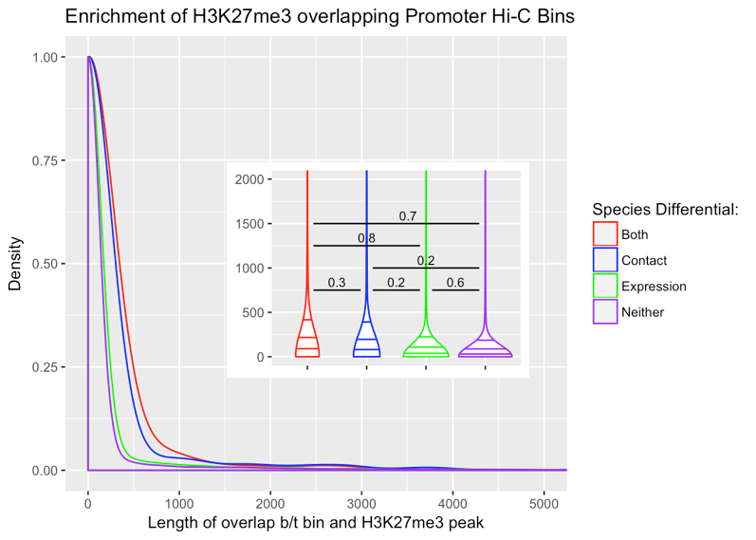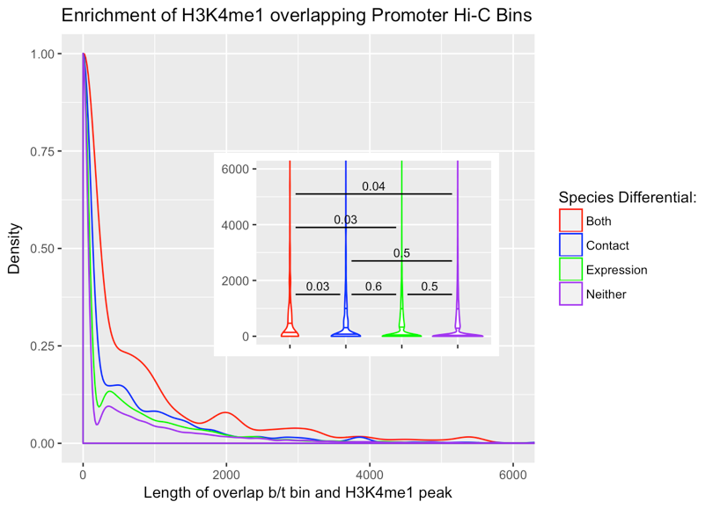

**Figure 7. Overlap Between a Variety of Histone Marks and our Hi-C Loci**

**A:** Density plot of base pair overlap between our Hi-C contact loci and H3K27ac (on the x-axis). Inlay displays a violin plot with 25th, 50th, and 75th percentiles marked as lines within the violin. Lines between different violin distributions and their corresponding numbers represent the significance value of t-testing for a difference in the means between the respective Hi-C locus classes’ base pair overlaps with H3K27ac. Of note is the strong significance seen in the difference in overlap between Hi-C contacts that are differential across species for both contact and expression (“both”) vs. those that are not differential at all (“neither”). Reassuringly, this latter class of hits is also depleted for H3K27ac overlap as compared to Hi-C loci that are solely differentially contacting or overlapping a differentially expressed gene.

**B:** Same as in A, but for H3K4me3. Note that many of the same relationships in A between different classes of Hi-C contact loci are recapitulated here, with an even starker difference in the class of contacts not involved in any differential category (“neither”) as compared to those that are.

**C:** Same as in A and B, but for H3K4me1. Once again, many of the same relationships between different classes of Hi-C contacts are seen, this time with slightly decreased significance.

**D:** Same as in A-C, but for the repressive histone mark H3K27me3 (A-C are active marks). Curiously, many of the same relationships between classes of Hi-C loci are once again seen, although none of the pairwise comparisons reach significance.

All histone mark data were obtained from ENCODE in experiments carried out in human iPSCs (A-C) or hESCs (D).

**C**

**D**

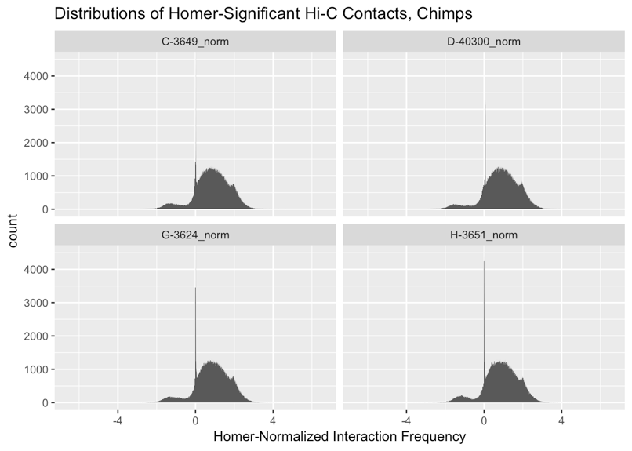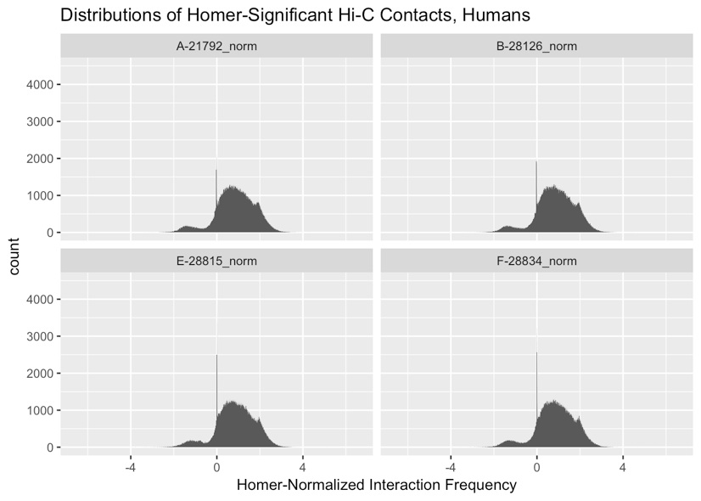

**B**

**A**

**Supplementary Figure 1. Distributions of Homer-Normalized Interaction Frequencies are Remarkably Similar Across Species**

**A:** Histogram of log2(observed/expected) HOMER-normalized interaction frequencies in all four human samples used in this study.

**B:** Same as in A, but for chimpanzees.

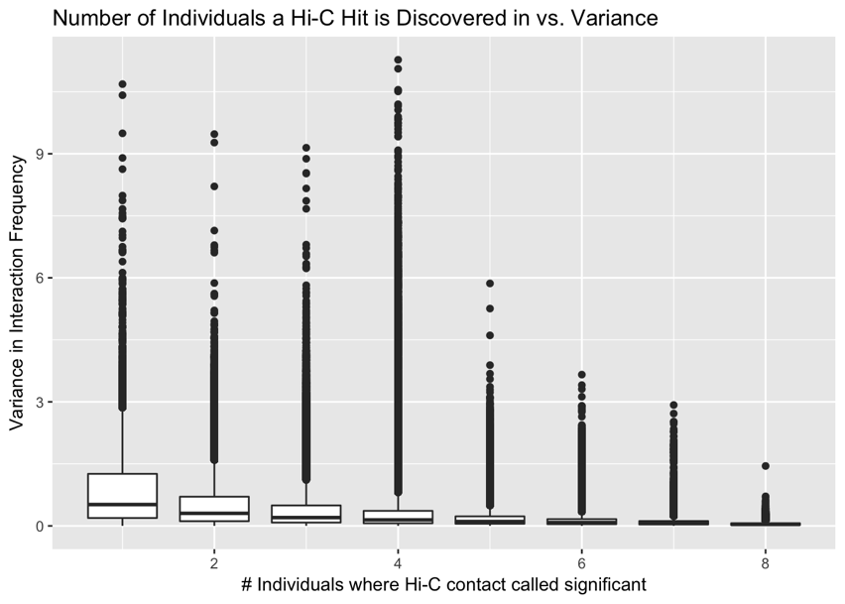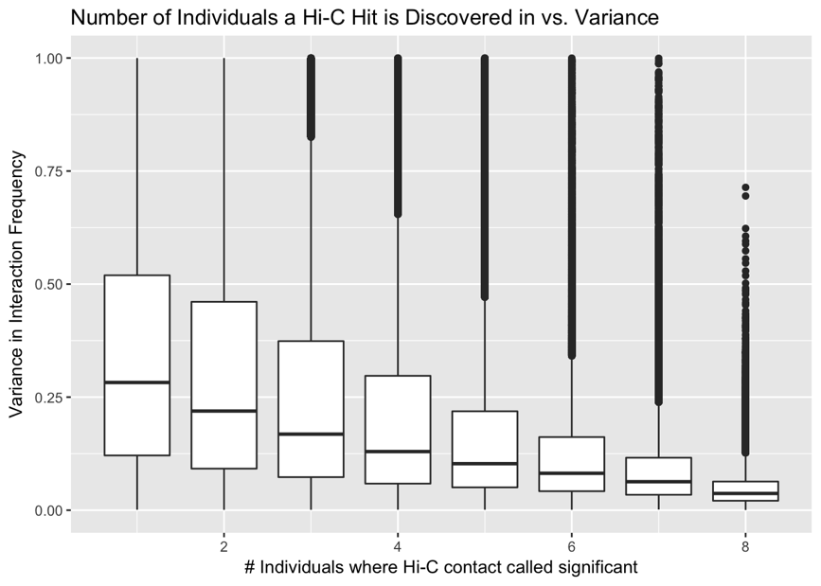

**Supplementary Figure 2. Variance in interaction frequency as a function of the number of individuals in which a significant interaction is independently discovered.**

**Left panel**: Boxplots of variance in contact frequency across all 8 individuals on the y-axis, binned by the number of individuals in which an interaction is independently called significant on the x-axis.

**Right panel:** Same as in left panel, but zoomed in on the y-axis to visualize finer-scale variation. A distinct monotonic trend is observed, with reductions in variance as an interaction is independently discovered in more individuals. This reduction appears to have diminishing returns after independently calling a Hi-C contact as statistically significant in more than four individuals, so a cutoff of discovery in at least four individuals was chosen to filter the data.

**A**

**Supplementary Figure 3. Volcano plot asymmetry quality control.**

**A:** Volcano plot showing log2 fold change in interaction frequency on the x-axis, and Benjamini-Hochberg corrected –log10 p-values on the y axis. Hits are colored by the species in which they were discovered significant in Homer (B-both, C-chimpanzees, H-humans). This plot shows data only filtered for independent discovery in at least 4 individuals. Strong asymmetry is observed, with many more inter-species significantly different interaction frequencies showing up on the left side, indicating overall increased contact in chimpanzees as compared to humans. Since this makes little biological sense, we sought to find technical differences that may explain this asymmetry.

**B:** 3-dimensional plot of sets of Hi-C contacts, with proportion of contacts significant at 5% FDR from linear modeling of interaction frequency on species on the x-axis. Contacts are binned by mate-pair distance differences on the y-axis, and bin size differences on the z-axis. Both of these issues may arise when using liftOver to convert the genomic coordinates of significant Hi-C contacts in one species to genomic coordinates for the other species. While changes in bin size appear to make marginal differences, large changes in the distance between mate pairs (≥20kb) created a noticeable inflation in the proportion of contacts significant at 5% FDR for linear modeling of interaction frequency on species. As this proportion clearly exceeded 5%, these hits were filtered out (red circles). Circle size indicates size of the set of Hi-C contacts falling into the given criteria.

**C:** Volcano plot as in A, but after removing contacts with large mate-pair distance differences across the species induced by liftOver. Notice the stark asymmetry seen in (A) has now disappeared. (I’m now also noticing this is on a drastically different scale on the y-axis as compared to the volcano plots before filtering—something must be wrong with that, I’ll check it out).

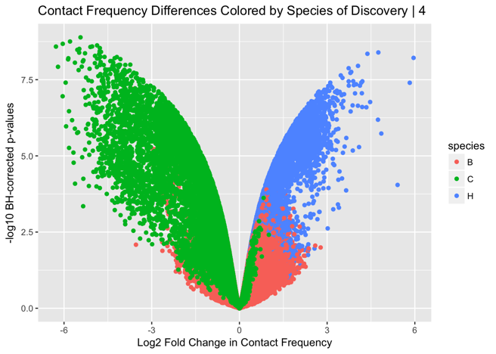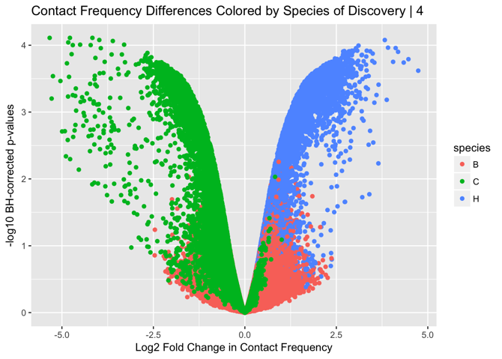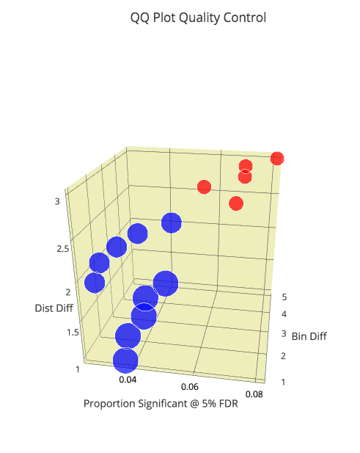

**B**

**C**

**Supplementary Figure 4. Correlations between Hi-C and Expression.**

**Left:** Distribution of Pearson correlations between RPKM expression values and log2 Homer-normalized contact frequencies are shown along the x-axis, with density on the y-axis. Solid line indicates observed data, dotted lines are for 1000 permutations. The Hi-C contact frequency being used here is once again that which represents the minimum FDR contact from linear modeling of contact frequency on species. Reassuringly, correlations for the permuted data have a stronger peak at zero than those for the observed data.

**Right**: Similar to panel on left, but this time only for differentially expressed (DE) genes. A strong bimodal distribution of correlations between expression and contact suggests many instances where a contact difference between the species can lead to an increase (enhancer) or decrease (suppressor) of expression in the species where the contact is stronger. Once again, permuted data show a strong peak at zero, indicating this is not merely a technical artifact. (yes I know the title for this panel is still mis-labeled)

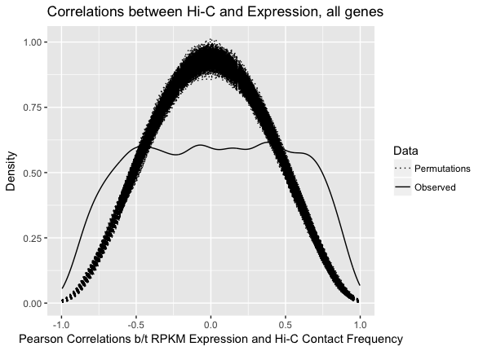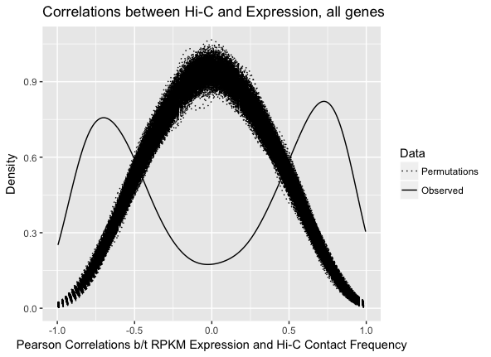

**Supplementary Figure 5. Inter-species expression differences are no longer significant when accounting for inter-species regulatory differences.**

**A:** Scatter plot of Benjamini-Hochberg corrected p-values obtained by testing the null hypothesis of no differences in gene expression levels between human and chimpanzee before (x-axis) and after (y-axis) regressing out each gene’s Hi-C contact strength. As in Fig. 4, the contact with the minimum FDR from linear regression of the Hi-C data on species is used. Solid red lines correspond to a 5% FDR threshold. Hits in the bottom right quadrant represent instances of decreased evidence for DE after regressing out Hi-C contact frequency, hits in the top left represent instances of increased evidence for DE after regression, and hits in the top right quadrant represent genes where equivalent evidence was seen for statistically significant DE before and after regression. (Do we want to include something on bottom left; should the figure in the actual paper be just on the DE genes to begin with as in Pai’s, b/c this is on entire gene dataset? And which of the permutations actually matter to show? Based on Pai paper it would just be the one in (B)).

**B:** Density plot of distribution, based on 1000 permutations, of the percentage of genes for which evidence for inter-species gene expression differences is expected to be reduced beneath statistical significance after correcting for Hi-C contact probability, by chance alone. Black shows the distribution for the permutations, red line represents observed percentage seen in the data.

**C:** Same as in (B), but this time looking at genes that show sustained evidence for a statistically significant difference in expression across species regardless of Hi-C correction.

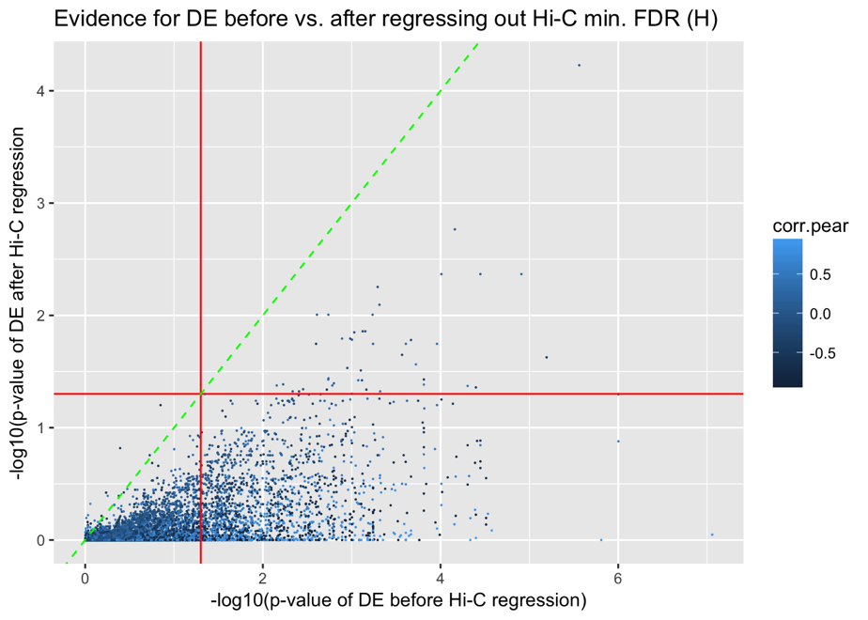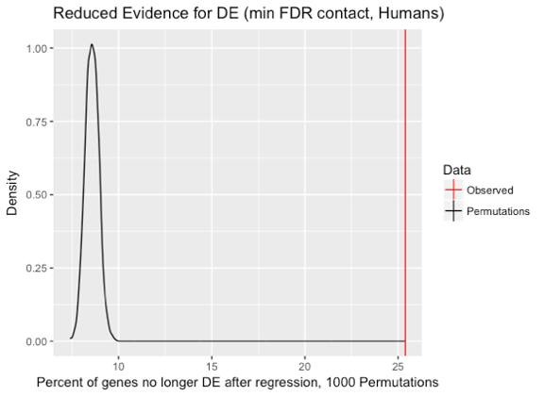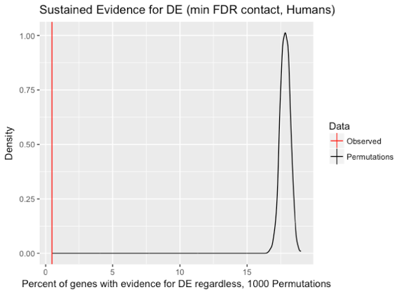

**B**

**C**

**A**

**B**

**A**

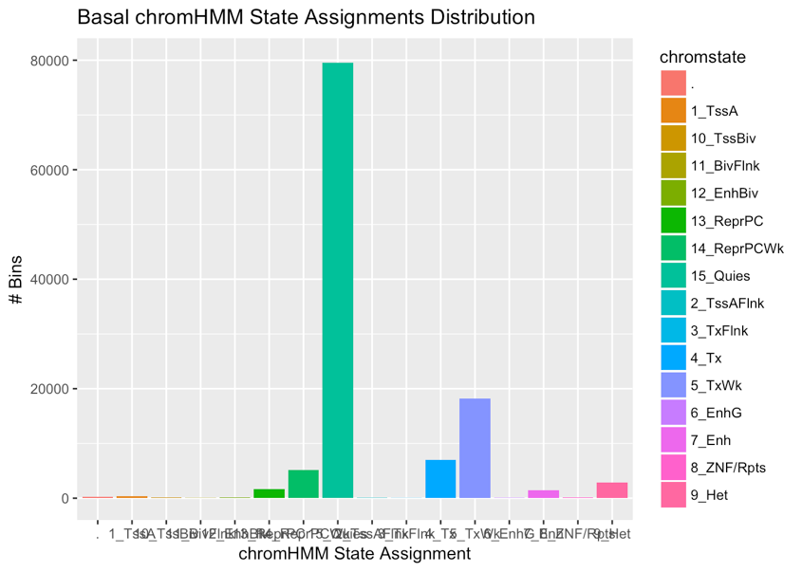

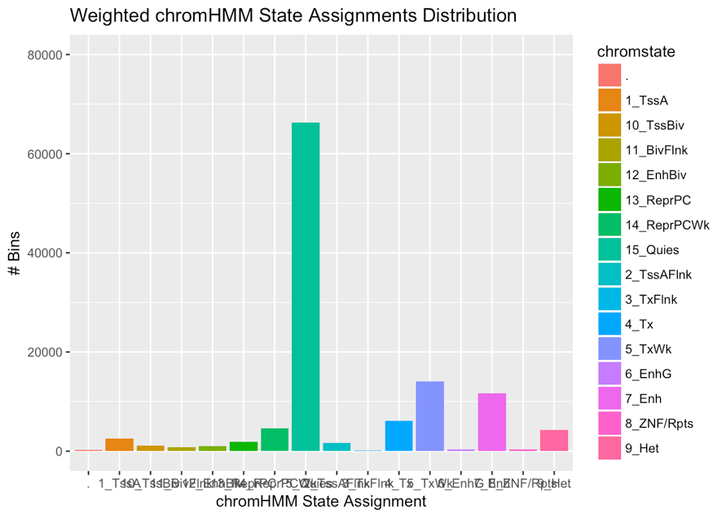

**Supplementary Figure 6. Using a Weighting Scheme for ChromHMM Annotations Increases the Proportion of Transcriptional and Enhancer-Like Annotations.**

**A:** Histogram of the number of Hi-C loci assigned to each chromHMM annotation when simply assigning each locus to whichever annotated element has the highest degree of base pair overlap.

**B:** Same as in (A), but this time doing assignment after weighting chromHMM elements’ overlaps with Hi-C loci by the reciprocal of their mean overlap in all our loci.

**A**

**B**

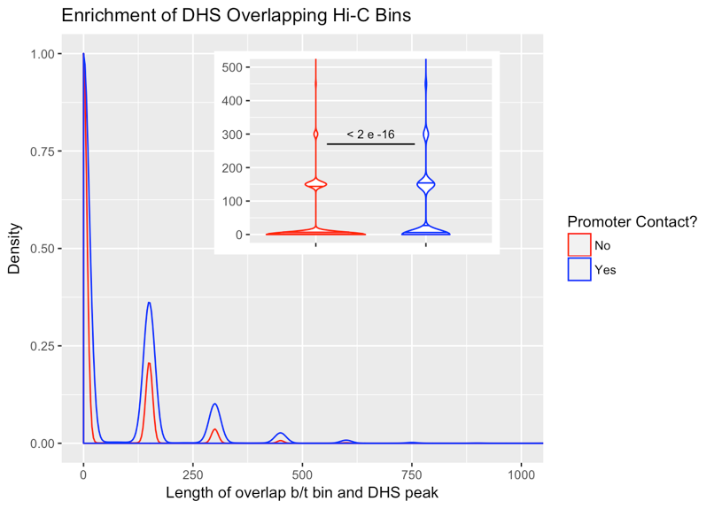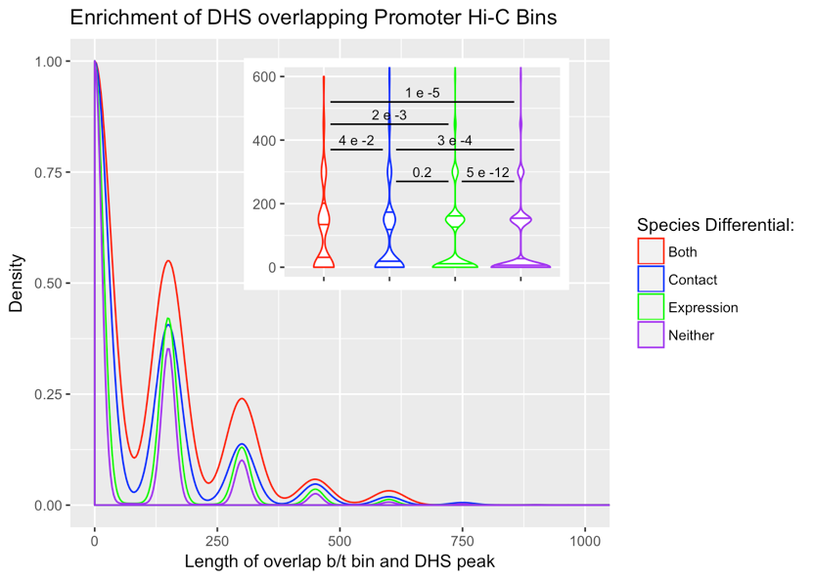

**Supplementary Figure 7.** **Our Significant Hi-C Loci are Enriched for DHS**

**A:** Density distribution of the base pair overlap between DHS peaks downloaded from ENCODE and our Hi-C loci. Plot is split between Hi-C loci that contact a promoter vs. those that do not. Inlay is a violin plot of the exact same distributions, with lines and numbers indicating pairwise t-tests of the mean, and their corresponding significance levels. As can be observed, there is a marked difference in chromatin accessibility (as measured by DHS) in contacts involving a promoter vs. those that do not.

**B:** Same as in (A), but this time, only looking amongst Hi-C loci involving contact with a promoter, and separating contacts into 4 different classes: those that show differential contact between species, those that show differential expression between species, those that show both, and those that show neither. The strong enrichment of DHS peaks in the set of differential hits of all categories corroborates the functional relevance of the loci identified with our approach.

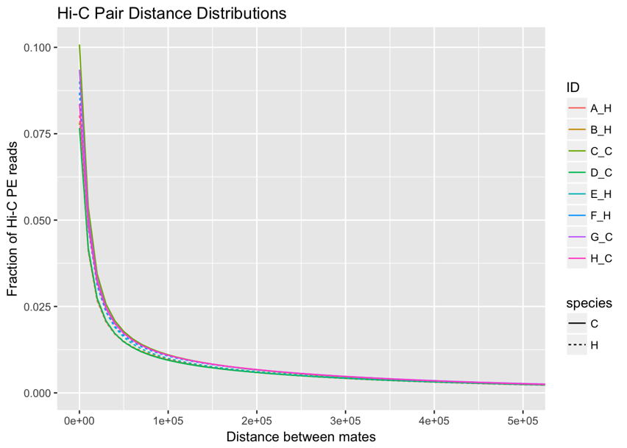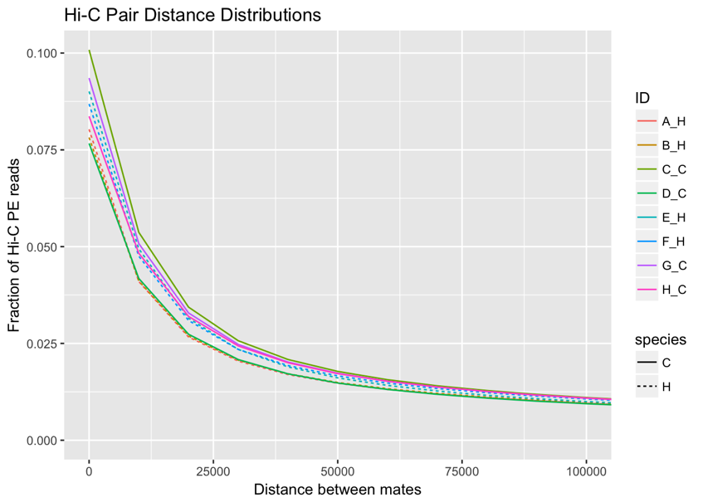

**Supplementary Figure 8.** **Distance distribution of paired-end reads from each library.**

**Left panel:** Fraction of paired-end (PE) reads representing mate pairs at different distances, in 10kb bins, shown colored differently for each individual library (ID). Dotted lines represent humans, and solid lines represent chimps. Reassuringly, we see no clear trend separating the species. Individual libraries from each species appear to have fractions of their PE reads at a given distance show up as both lower and higher than other individuals in the same or a different species.

**Right panel:** Zoom of left panel on x-axis to show degree of separation between libraries on a smaller scale. Again, human libraries and chimp libraries do not seem to be clustering separately here.